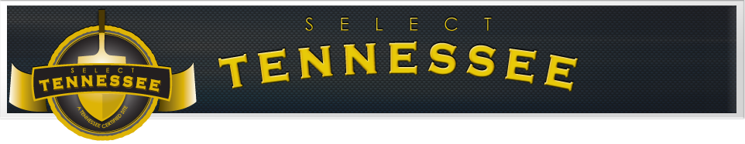
Huntingdon Industrial Park South
SITE OVERVIEW
Site Address: State Highway 22 and Clyde Road
City (where site is located): Huntingdon
County (where site is located): Carroll
Site ownership: Public
Site acreage: 92 acres | UTILITY SERVICE
Developable acreage: 57 acres | Electric line serving site: 13 kV
Additional acreage available: N/A | Electric service to substation: 69 kV
For sale or lease: Sale | Dual feed service: Not Available
Sale/Lease price: $10,000 per acre | Natural gas service: 12 inch line / 325 psi
Zoning: M-2 (General Industrial) | Water line serving site: 8 inch
Site covenants: No | Water system capacity: 1.67 MGD
Impact fees: No | Excess water system capacity: 0.76 MGD
Foreign trade zone: No | Wastewater line serving site: 8 inch
Distance to four-lane highway: Adjacent | Wastewater system capacity: 650,000 GD
Rail service: Not Available | Excess wastewater capacity: 375,000 GD
TECHNICAL STUDIES AND REPORTS
Two foot topographic survey: Available | Geotechnical survey: Available
Site grading plan/design: Not Available | Flood hazard: Outside Flood Plain
Phase 1 ESA: Available (September 2017) | Endangered species review: Available
Hydrologic determination: Available | Cultural resource review: Available

